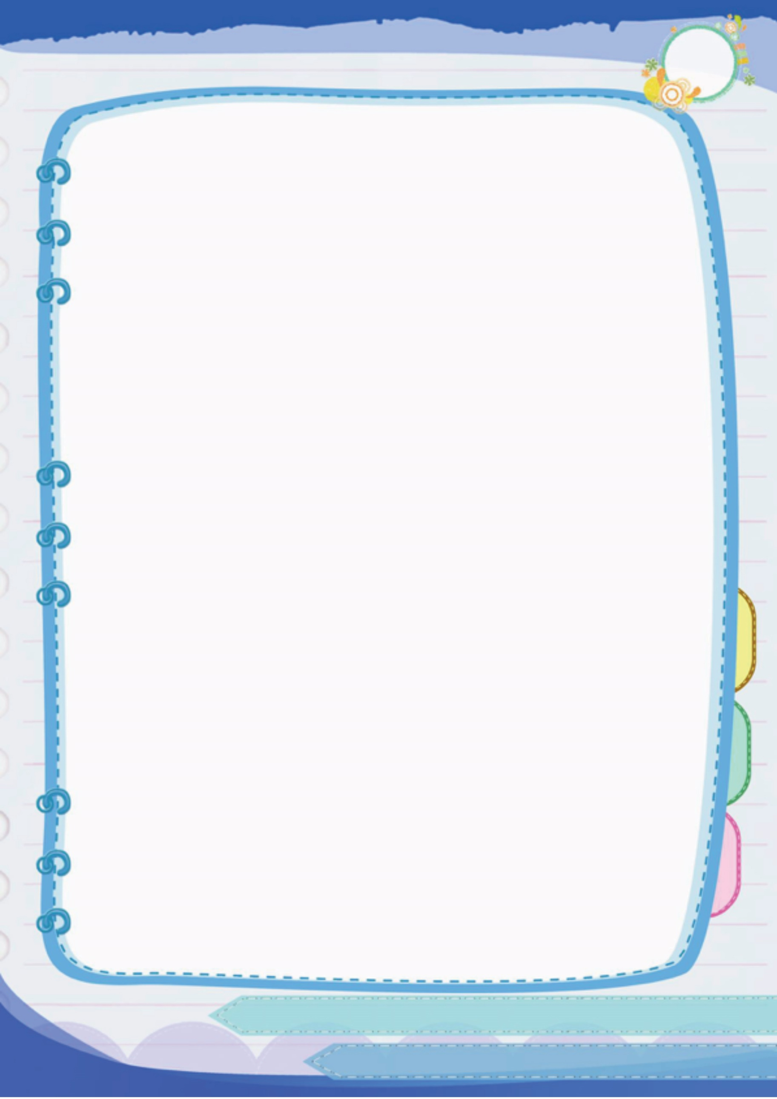
ชื่อ-สกุล.....................................................................................เลขที่..............ชั้น............

แบบฝึกหัด เรื่อง การสร้างสไลด์แบบต่าง ๆ
คำชี้แจง ให้นักเรียนตอบคำถามต่อไปนี้ให้ถูกต้องและสมบูรณ์ที่สุด

1. สร้างสไลด์แบบตัวช่วยสร้างเนื้อหาอัตโนมัติมีลักษณะอย่างไร
...................................................................................................................................................
...................................................................................................................................................
...................................................................................................................................................
...................................................................................................................................................
...................................................................................................................................................
...................................................................................................................................................
2. สร้างสไลด์แบบแม่แบบมีลักษณะอย่างไร
...................................................................................................................................................
...................................................................................................................................................
...................................................................................................................................................
...................................................................................................................................................
...................................................................................................................................................
...................................................................................................................................................
3. สร้างสไลด์แบบงานนำเสนอเปล่ามีลักษณะอย่างไร
...................................................................................................................................................
...................................................................................................................................................
...................................................................................................................................................
...................................................................................................................................................
...................................................................................................................................................
...................................................................................................................................................



